AWG-5
Prescribed by Secretary of State
Sections 87.022 - 87.025, Texas Election Code 3/07

NOTICE OF CONVENING OF EARLY VOTING BALLOT BOARD
AVISO DE CONVOCATORIA DE LA JUNTA ELECTORAL DE VOTACl6N ANTICIPADA

TO: Early Voting Clerk and Custodian of Ballot Box Key
Para: Secretario de votaci6n ant;cipada y custodio de la /lave de la urna

The Early Voting Ballot Board will convene at the following dates and times for the purpose of qualifying and/or counting the early voting ballots cast in the election held on May 4, 2024. The Early Voting Ballot Board will meet at 1308 Crickets Avenue, Lubbock, Texas.

You are hereby instructed to deliver all election materials, ballots voted by mail, double-locked ballot box(es), and the keys to the ballot box(es) to me at the times designated.

la Junta de Bo/etas de Votaci6n Anticipada se reunira en las siguientes fechas y horas con el fin de calificar y/o contar las boletas de votaci6n anticipada emitidas en la elecci6n ce/ebrada el 4 de mayo de 2024. la Junta de Bo/etas de Votaci6n Anticipada se reunira en 1308 Crickets Avenue, Lubbock, Texas.

Por la presente, se le indica que me entregue todos los materiales electorales, las boletas votadas por correo, las urnas con doble candado y las /laves de las urnas en el momenta indicado anteriormente.

Time[Hora Date[Fecha

10:00 am April 23, 2024
23 de abril de 2024

10:00 am

10:00 am
May 1, 2024
1 de mayo de 2024

May 4, 2024
4 de mayo de 2024

10:00 am May 10, 2024
10 de mayo de 2024

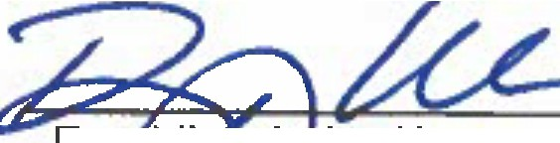
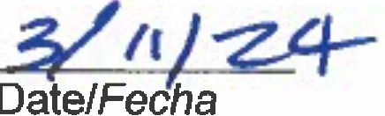
Pr Jtfdge/Juez que preside EatfyVoting Ballot Board/
Junta de boletas de votaci6n anticipada

