
Request for Proposals (RFP)
to Lease Agriculture Land

Issued by:
City of Abernathy, Texas
March 12, 2026

The original signed proposal, two (2) duplicates are to be submitted in sealed packages with the name of the Proposer and RFP title clearly marked on the outside of the package.

All proposals shall be addressed and delivered to:
City of Abernathy
Attn: Julie Arrington, City Administrator
811 Avenue D
PO Box 310
Abernathy, Texas 79311

Proposals must be received in sealed envelopes or packages
no later than 10:00 A.M. Central Standard Time on Tuesday, April 7, 2026

NOTICE TO PROPOSERS

The City of Abernathy, Texas (the “City”) is seeking proposals from qualified parties interested in leasing two (2) parcels of certain real property from the City for agricultural use, specifically for Farming. The successful proposer may be chosen to enter a long-term lease for the Property. Proposers may submit proposals for either one of the two parcels, or for both.

The City reserves the right to reject any and all proposals and to waive any minor informalities or irregularities contained in any proposal. Acceptance of any proposal submitted pursuant to this RFP shall not constitute any implied intent to enter into a lease. The City reserves the right to call for new proposals, and to award the lease to another party if deemed to be in the best interest of the City.

The City reserves the right to cancel, for any or no reason, in part or in its entirety, this RFP. If the City cancels the RFP, all proposers will be notified in writing.
The award, if any, will be made to the party or parties who, in the City’s sole discretion, submit proposals deemed to be in the best interest of the City. The City shall be the sole judge of its own best interest, the proposal, and the resulting, negotiated lease. The City’s decisions will be final.
Proposals may be withdrawn any time prior to the official opening. Request for non-consideration of proposals must be made in writing to the City Manager.
The City will NOT be responsible for any costs incurred by any proposer in the preparation or submittal of their respective proposal.
Questions regarding this RFP are to be directed by email to: Julie Arrington, City Administrator, at j.arrington@cityofabernathy.org for clarification purposes only and must be received by 12 P.M. Central Standard Time on Tuesday, March 31, 2026. Material changes, if any, to the scope of this RFP or its procedures will only be transmitted by written addenda to be posted on the City website. Prospective proposers are responsible for checking the City website (www.cityofabernathy.org) for addenda to this RFP.
All proposers should be aware that all documents submitted are subject to disclosure under the Texas Public Information Act (Government Code Section 552).

Proposals must be received in sealed envelopes or packages no later than 10:00 A.M. Central Standard Time on Tuesday, April 7, 2026.

Proposals will be opened and read aloud at 10:00 A.M. Central Standard Time on Tuesday, April 7, 2026 at Abernathy City Hall, 811 Avenue D, Abernathy, Texas 79311.

Section I: Background and General Information

The City of Abernathy, Texas (the “City”) is seeking proposals from qualified parties interested in leasing two (2) parcels of certain real property from the City for agricultural use, specifically for Crop Cultivation. The successful proposer may be chosen to enter a long-term lease for the Property. Proposers may submit proposals for either of the two parcels, or for both. This RFP provides background and general information for Proposers and is to be used as a guideline to develop a proposal.

Section II: Specifications
- The Property

Parcel 1:

Property Location:
Approximately 7.5 miles East-Northeast of the City of Abernathy, south of FM 54 and west of FM 400.
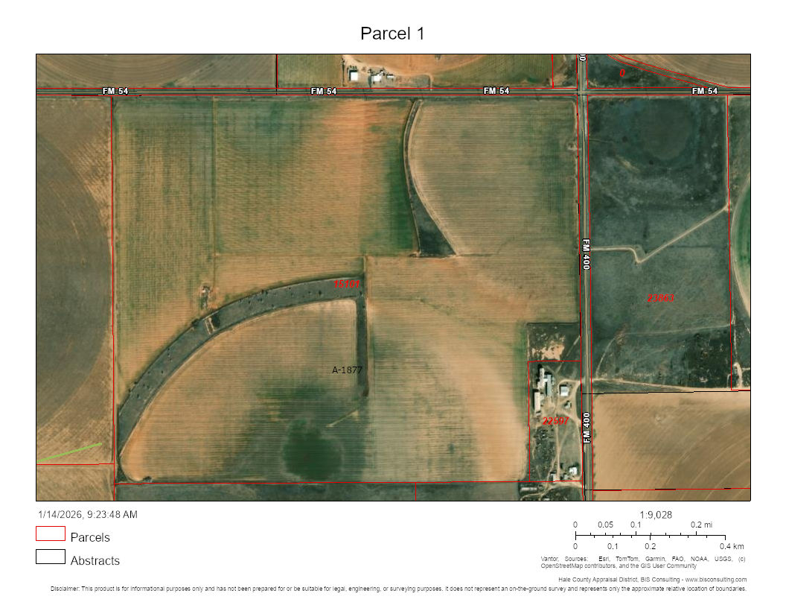

Size:
Approximately 282 contiguous acres, fenced and unimproved, and not including the property immediately surrounding the City’s water wells.

Legal Description:
AB 1877 BLK S SEC 14 N 299.372 OF N 320.6 EX TR IN SE/C JACK SCOTT
Hale County Appraisal District Property ID No. 15101

Use:
The land must be used exclusively for agricultural purposes, specifically for Crop Cultivation. Pasture and grazing of animals such as cattle, horses, or goats or other commercial uses not aligned with crop cultivation may also be considered.

Utilities:
No utilities (water or electric) are currently available on the land. Lessee will be responsible for any necessary improvements or access needs, subject to the City’s prior approval.

Parcel 2:

Property Location:
Approximately 8.3 miles Northeast of the City of Abernathy, south of County Road 295 and west of FM 400.
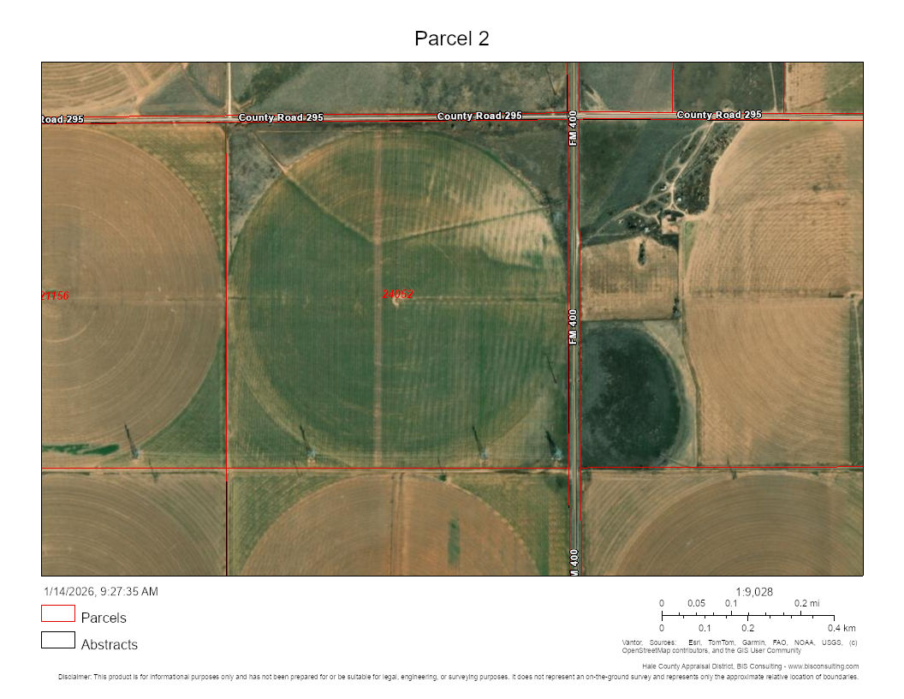

Size:
Approximately 160 contiguous acres, fenced and unimproved.

Legal Description:
AB 1690 BLK CL SEC 22 NE/4 160 ACRES
Hale County Appraisal District Property ID No. 24052

Use:
The land must be used exclusively for agricultural purposes, specifically for Crop Cultivation. Pasture and grazing of animals such as cattle, horses, or goats or other commercial uses not aligned with crop cultivation may also be considered under this RFP.

Utilities:
No utilities (water or electric) are currently available on the land. Lessee will be responsible for any necessary improvements or access needs, subject to the City’s prior approval.

- Terms of Agreement

The successful proposer will enter into a lease agreement with the City, with terms and parcel-specific details to be determined by the City. The proposed term of the lease is five (5) years with one (1) five-year option to renew. A copy of the City’s proposed form of lease is attached hereto as Exhibit A. However, the City reserves the right to revise the terms of the lease, at the City’s sole discretion.

Section III: Scope

- Selection Criteria

Although not intended to be an all-inclusive list, the following factors will be evaluated when selecting a proposal:
- The proposer’s intended use of the property;
- The proposer’s background and experience with agricultural or ranching operations; and
- The proposed annual, per-acre annual rental rate.

- Notice of Acceptance of Proposal
Upon the City’s selection of a proposal, the selected proposer will be notified of the selection, by telephone or email, no later than Tuesday, April 14, 2026, of the selection. However, any resulting lease will be subject to the approval of the City Council of the City of Abernathy at an open and public City Council meeting.

Section IV: PROPOSAL CALENDAR

The following is a list of key dates up to, and including, the tentative award:
DATE | ACTIVITY
Friday, March 13, 2026 | RFP Released
Tuesday, March 31, 2026 at 12:00 noon | Questions Due
Tuesday, April 7, 2026 at 10:00 A.M. | Proposals Due &Bid Opening
Monday, April 13, 2026 | City Council approval and award

Exhibit A
Form of Lease

City of Abernathy

Agricultural Lease
Basic Information
Date: __________________________
Landlord: City of Abernathy, a Type A general law municipality of the State of Texas
Landlord’s Address: PO Box 310, Abernathy, Texas 79311
Tenant: ______________________________________
Tenant’s Address: _________________________________________________
Premises: SURFACE ONLY of approximately _________________ acres of land, situated in Hale County, Texas, as further described and depicted in Exhibit A, attached hereto and incorporated herein for all purposes (“Land”).
The Premises does not include and Tenant will not be permitted to use the Excluded Improvements.
Excluded Improvements: Any structure, improvement, or equipment situated on the Land and constructed or installed by any person other than Tenant.
Base Rent: ____________________________ ($__________.00) per year, pro-rated and payable in monthly installments, each due and payable to Landlord no later than the tenth (10th) day of each month during the Term.
Term (years): Five (5) years; one five-year renewal term at Landlord’s option
Commencement Date: _________________________
Termination Date: _________________________
Security Deposit: None
Permitted Use: Solely for pasture and animal grazing, or other agricultural purposes.
Tenant’s Insurance: As required by Insurance Addendum
- Definitions
A.1. “Agent” means agents, employees, officers, directors, members and partners of the principal, and, to the extent under the control of the principal, invitees.
A.2. “Injury” means (a) harm to or impairment or loss of property or its use or (b) harm to or death of a person.
A.3. “Rent” means Base Rent plus any other amounts of money payable by Tenant to Landlord.
- Tenant’s Obligations
B.1. Tenant agrees to—
B.1.a. Lease the Premises for the entire Term beginning on the Commencement Date and ending on the Termination Date.
B.1.b. Accept the Premises in their present condition “AS IS,” the Premises being currently suitable for the Permitted Use.
B.1.c. Obey all laws relating to Tenant’s use, maintenance of condition, and occupancy of the Premises, including the rules and regulations of the United States Department of Agriculture and the Texas Agriculture Commissioner.
B.1.d. Pay the Base Rent when it is due, without demand, to Landlord at Landlord’s Address.
B.1.e. Pay a late charge of five (5) percent of any Rent not received by Landlord by the tenth day after it is due.
B.1.f. Pay for all labor, fuel, and utility services used by Tenant.
B.1.g. Pay all taxes on the crops raised on and Tenant’s property located on the Premises.
B.1.h. Allow Landlord to enter the Premises to inspect the Premises and show the Premises to prospective purchasers or tenants.
B.1.i. Repair, replace, and maintain any part of the Premises used by Tenant.
B.1.j. Repair any damage to the Premises, Land, or Excluded Improvements caused by Tenant.
B.1.k. Maintain the insurance coverages described in the attached Insurance Addendum.
B.1.l. Indemnify, defend, and hold Landlord and Landlord’s Agents, successors, and assigns harmless from any Injury (and any resulting or related claim, action, loss, liability, or reasonable expense, including attorney’s fees and other fees and court and other costs) arising out of Tenant’s or Tenant’s Agents’, successors’, and assigns’ use of the Premises if caused in whole or in part by the acts or omissions of Tenant, its Agents, successors, and assigns, or those acting on Tenant’s behalf, including in whole or in part by their negligent acts or omissions. The indemnity contained in this paragraph (i) is independent of Tenant’s Insurance, (ii) will not be limited by comparative negligence statutes or damages paid under the Workers’ Compensation Act or similar employee benefit acts, (iii) will survive the end of the Term, and (iv) will apply even if an Injury is caused in part by the ordinary negligence or strict liability of Landlord or Landlord’s Agents, successors, and assigns but will not apply to the extent an Injury is caused in whole or in part by the gross negligence or willful misconduct of Landlord or Landlord’s Agents, successors, and assigns.
B.1.m. Vacate the Premises on the last day of the Term.
B.1.n. Pay all costs of grazing or pasturing animals and planting, raising, and harvesting the crops.
B.1.o. Cultivate the Premises in a timely, thorough, and farmer-like manner, employing the best methods of farming and ranching customarily practiced in the area.
B.1.p. Maintain adequate records on all matters related to farming the Premises and provide Landlord with a copy.
B.1.q. Keep all gates on the Premises closed and locked.
B.1.r. Enter and exit the Premises only at those places designated by Landlord.
B.2. Tenant agrees not to—
B.2.a. Use the Premises for any purpose other than the Permitted Use.
B.2.b. Create or allow a nuisance or permit any waste of the Premises.
B.2.c. Change Landlord’s lock system.
B.2.d. Alter the Premises, including clearing new roads, moving or erecting any fences, or locating on the Premises any type of manufactured housing or mobile home.
B.2.e. Assign this lease or sublease any portion of the Premises without Landlord’s written consent.
B.2.f. Make any new or change any existing agreement with any governmental entity.
B.2.g. Hunt or fish on the Land or allow anyone else to do so.
B.2.h. Litter or leave trash or debris on the Premises.
B.2.i. Allow a lien to be placed on the Premises.
B.2.j. Allow a lien to be placed on the crops raised on or harvested from the Premises.
- Landlord’s Obligations
C.1. Landlord agrees to—
C.1.a. Lease to Tenant the Premises for the entire Term beginning on the Commencement Date and ending on the Termination Date.
C.1.b. Return the Security Deposit to Tenant, less itemized deductions, if any, on or before the sixtieth day after the date Tenant surrenders the Premises.
C.1.c. Obey all laws relating to Landlord’s operation of the Premises.
C.2. Landlord agrees not to—
C.2.a. Allow any use of the Premises inconsistent with the Permitted Use as long as Tenant is not in default.
- General Provisions
Landlord and Tenant agree to the following:
D.1. Alterations. Any physical additions or improvements to the Premises made by Tenant will become the property of Landlord. Landlord may require that Tenant, at termination of this lease and at Tenant’s expense, remove any physical additions and improvements, repair any alterations, and restore the Premises to the condition existing at the Commencement Date, normal wear excepted.
D.2. Abatement. Tenant’s covenant to pay Rent and Landlord’s covenants are independent. Except as otherwise provided, Tenant may not abate Rent for any reason.
D.3. Release of Claims/Subrogation. Tenant releases Landlord and Landlord’s Agents, successors, and assigns from all claims or liabilities for any Injury to Tenant or Tenant’s Agents, successors, and assigns or to Tenant’s or Tenant’s Agents’, successors’, and assigns’ property located on the Premises. The release in this paragraph will apply even if the damage or loss is caused, in whole or in part, by the ordinary negligence or strict liability of Landlord or Landlord’s Agents, successors, and assigns but will not apply to the extent the damage or loss is caused in whole or in part by the gross negligence or willful misconduct of Landlord or Landlord’s Agents, successors, and assigns.
D.4. Condemnation/Substantial or Partial Taking
D.4.a. If the Premises cannot be used for the Permitted Use because of condemnation or purchase in lieu of condemnation, this lease will terminate.
D.4.b. If there is a condemnation or purchase in lieu of condemnation and this lease is not terminated, the Rent payable during the unexpired portion of the Term will be adjusted as may be fair and reasonable.
D.4.c. Tenant will have no claim to the condemnation award or proceeds in lieu of condemnation.
D.5. Default by Landlord/Events. A default by Landlord is the failure to comply with any provision of this lease that is not cured within thirty (30) days after written notice.
D.6. Default by Landlord/Tenant’s Remedies. Tenant’s sole remedy for Landlord’s default is to terminate this lease. Tenant may not terminate under this paragraph while in arrears for Rent.
D.7. Default by Tenant/Events. Defaults by Tenant are (a) failing to pay Rent timely, (b) abandoning the Premises or vacating a substantial portion of the Premises, and (c) failing to comply within ten days after written notice with any provision of this lease other than the defaults set forth in (a) and (b).
D.8. Default by Tenant/Landlord’s Remedies. Landlord’s remedies for Tenant’s default are to (a) enter and take possession of the Premises and sue for Rent as it accrues; (b) enter and take possession of the Premises, after which Landlord may relet the Premises on behalf of Tenant and receive the Rent directly by reason of the reletting, and Tenant agrees to reimburse Landlord for any expenditures made in order to relet; (c) enter the Premises and perform Tenant’s obligations; and (d) terminate this lease by written notice and sue for damages. Landlord may enter and take possession of the Premises by self-help, by picking or changing locks if necessary, and may lock out Tenant or any other person who may be farming the Premises, until the default is cured, without being liable for damages.
D.9. Default/Waiver. All waivers must be in writing and signed by the waiving party. Landlord’s failure to enforce any provisions of this lease or its acceptance of late installments of Rent will not be a waiver and will not estop Landlord from enforcing that provision or any other provision of this lease in the future.
D.10. Mitigation. Landlord and Tenant have a duty to mitigate.
D.11. Security Deposit. If Tenant defaults, Landlord may use the Security Deposit to pay arrears of Rent, to repair any damage or injury, or to pay any expense or liability incurred by Landlord as a result of the default.
D.12. Holdover. If Tenant does not vacate the Premises following termination of this lease, Tenant will become a tenant at will and must vacate the Premises on receipt of notice from Landlord. No holding over by Tenant, whether with or without the consent of Landlord, will extend the Term.
D.13. Attorney’s Fees. If either party retains an attorney to enforce this lease, the party prevailing in litigation is entitled to recover reasonable attorney’s fees and other fees and court and other costs.
D.14. Choice of Law and Venue. The provisions of this lease are contractual and not mere recitals and this lease shall be governed by and will be construed by the laws of the State of Texas. This lease is to be construed under Texas law, and all obligations of the parties created by this lease are performable in Hale County, Texas. Venue for any action brought pursuant to this lease shall lie exclusively in Hale County, Texas.
D.15. Entire Agreement. This lease and its exhibits, addenda, and riders are the entire agreement of the parties concerning the lease of the Premises by Landlord to Tenant. Landlord has not made and does not make any representations about the commercial suitability, physical condition, layout, footage, expenses, or operation of the Premises or any other matter affecting or relating to the Premises and this agreement, except as specifically set forth in this lease. As an inducement to Landlord to enter into this lease, Tenant expressly acknowledges and warrants that no such representations have been made and Tenant is not relying on any representations not contained in this lease and any exhibits, addenda, and riders.
D.16. Amendment of Lease. This lease may be amended only by an instrument in writing signed by Landlord and Tenant.
D.17. Limitation of Warranties. There are no implied warranties of suitability, of merchantability, of fitness for a particular purpose, or of any other kind arising out of this lease, and there are no warranties that extend beyond those expressly stated in this lease.
D.18. Notices. Any notice required or permitted under this lease must be in writing. Any notice required by this lease will be deemed to be given (whether received or not) the earlier of receipt or three business days after being deposited with the United States Postal Service, postage prepaid, certified mail, return receipt requested, and addressed to the intended recipient at the address shown in this lease. Notice may also be given by regular mail, personal delivery, courier delivery, or email and will be effective when received. Any address for notice may be changed by written notice given as provided herein.
D.19. Groundwater and Mineral Interests. This lease is subordinate to any present or future groundwater, or oil, gas, or other mineral exploration agreements and leases relating to the Land. Landlord will not be liable to Tenant for any damages for actions attributable to those agreements and will receive all consideration paid therefor.
D.20. Landlord’s Use. Landlord retains the right to enter on and use and/or permit third parties to enter on and use the Premises for any public purpose, provided that Landlord will use reasonable efforts to avoid any material interfere with Tenant’s farming rights.
D.21. Tenant’s Use of Water. Tenant shall not be permitted to use the groundwater located beneath the Land.
D.22. Severability. If any portion of this lease is held unenforceable by a court of competent jurisdiction, the remainder of this lease shall not be affected and shall remain fully in force and enforceable.
D.23. Governmental Powers. It is understood and agreed that by execution of this lease, Landlord does not waive or surrender any of its governmental powers or immunities.

Landlord:
City of Abernathy, a Type A general law municipality of the State of Texas

By:________________________________
Harold Bufe

Attest: ________________________________
Krista Adames, City Secretary

Tenant:
________________________________________

By:________________________________
Name: _____________________________
Title: ______________________________

Insurance Addendum to Lease
Lease
Date:
Landlord:
Tenant:
This insurance addendum is part of the lease.
Tenant agrees to—
1. Maintain the liability insurance policies required below (mark applicable boxes) during the Term and any period before or after the Term when Tenant is present on the Premises:

Type of Insurance |  | Minimum Policy Limit
□ | Commercial general liability (occurrence basis) endorsed to cover farm operations | Per occurrence: | $____________
 |  | Aggregate: | $____________
Or
□ | Farm owner’s on a renter’s form such as AAIS Form No. FO-4
Or
□ | Farm liability policy
□ | Workers’ compensation | $500,000
□ | Employer’s liability | $____________
□ | Business automobile liability | $____________
□ | Umbrella/excess liability (occurrence basis) | $____________
2. Comply with the following additional insurance requirements:
a. All liability policies must be endorsed to name Landlord as an “additional insured” on a form that does not exclude coverage for the sole or contributory ordinary negligence of Landlord and must not be endorsed to exclude the sole negligence of Landlord from the definition of “insured contract.”
b. Certificates of insurance and copies of any additional insured and waiver of subrogation endorsements must be delivered by Tenant to Landlord before entering the Premises and thereafter at least ten days before the expiration of the policies.

