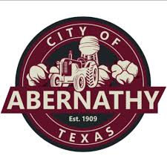

Notice to Bidders

  - The City of Abernathy is seeking bids for a Farm Land Lease.

  - For a detailed list of requirements and specifications, contact:

  - Julie Arrington
  - P.O. Box 310
  - Abernathy, TX 79311
  - 806-298-2546
  - j.arrington@cityofabernathy.org

  - The Abernathy City Council reserves the right to reject any and all bids and may accept any bid deemed to be most advantageous to the City of Abernathy.

  - Proposals must be received in sealed envelopes or packages no later than 10:00 A.M. Central Standard Time on Tuesday, April 7, 2026

